# Module Specification:

CIM Level 4 Award in Planning Campaigns(VRQ)

Planning Campaigns is a 17-credit mandatory module which sits within the suite of

Level 4 modules.

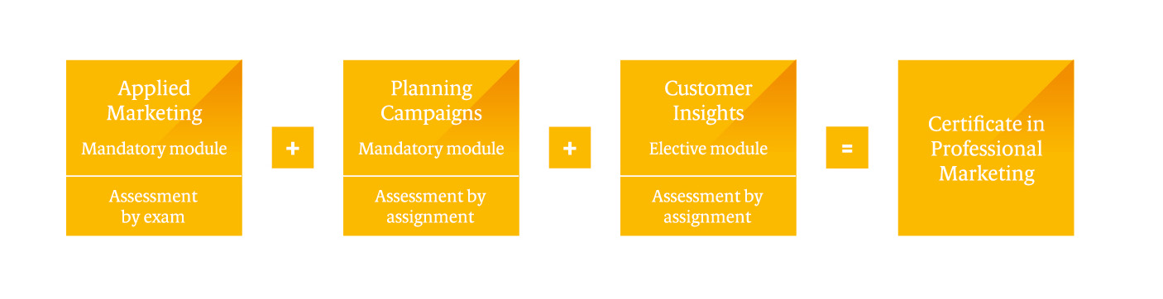

Planning Campaigns is common to both CIM Level 4 Certificate qualifications. To gain the CIM Level 4 Certificate in Professional Marketing, a pass in Applied Marketing, Planning Campaigns plus Customer Insights is required.

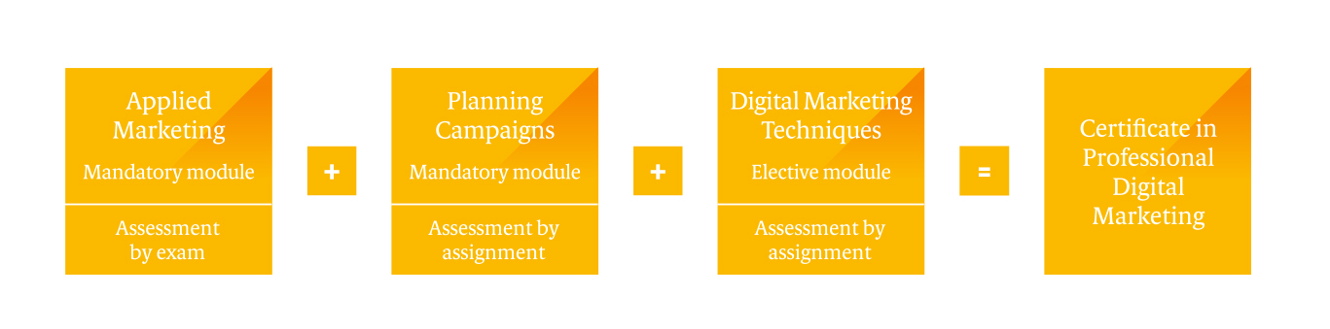

To gain the CIM Level 4 Certificate in Professional Digital Marketing, a pass in Applied Marketing, Planning Campaigns plus Digital Marketing Techniques is required.

If studied as a standalone module, the CIM Level 4 Award in Planning Campaigns (VRQ) can be achieved.

## Aim of the module

This module gives you the knowledge and skills to plan and implement successful campaigns that deliver real results for an organisation. You will learn the campaign planning process including how to analyse an organisation’s current position. You will also learn how to set campaign objectives, implement a campaign then measure and evaluate its success to aid continuous improvement in the fast-changing world of marketing.

## Module structure

The module comprises three units of two learning outcomes each. Each learning outcome will be covered by the related assessment criteria and will be assessed by way of assignment. The assessment will require submission of an assignment based on a theme and an organisation of choice.

The learning outcomes and assessment criteria, along with the indicative content, are detailed in the Planning Campaigns module content which follows.

## CIM Level 4 Certificate in Professional Marketing (VRQ)/CIM Level 4 Certificate in Professional Digital Marketing (VRQ) Qualification Specifications

Please refer to the CIM Level 4 Certificate in Professional Marketing/CIM Level 4 Certificate in Professional Digital Marketing Qualification Specifications for all other information including:

* CIM Professional Marketing Competencies
* The Level 4 qualification structure
* Who it is for
* Entry requirements
* The Modular Pathway
* Progression
* Credits and Total Qualification Time (TQT)
* Modes of study
* How it is assessed – assessment methodology
* How the assessments are delivered and when
* How it is graded
* When are results issued?
* Module specifications
* What we mean by command words

## Module Content: Planning Campaigns (mandatory)

|  |  |  |
| --- | --- | --- |
| Level 4 | Credit value: 17 | Total Qualification Time: 170 hours  Guided Learning Hours: 150 hours |

**Purpose statement**

|  |
| --- |
| This module covers the planning of effective marketing campaigns and the processes for developing relevant marketing activities to influence customers. The module comprises of three units: the first unit develops knowledge about the campaign planning process; the second unit develops the skills and knowledge to prepare and implement an effective marketing campaign plan; and the third unit develops knowledge and application skills to measure and monitor the results of marketing campaigns. |

**Assessment**  **Module weighting**

|  |  |  |
| --- | --- | --- |
| Organisation based assignment |  | LO 1 – 15% weighting  LO 2 – 15% weighting  LO 3 – 30% weighting  LO 4 – 20% weighting  LO 5 – 10% weighting  LO 6 – 10% weighting |

|  |
| --- |
| **Overarching learning outcomes**  By the end of this module learners should be able to: |
| **Campaign Process**   * Understand the process of planning a campaign * Know how to undertake an internal and external situational analysis   **Planning Campaigns in Action**   * Know how to develop a successful campaign plan * Understand how to implement a plan in practice   **Campaign Success**   * Understand the principles of monitoring a marketing campaign * Know how to undertake a post campaign evaluation |

## Unit 1: Campaign Process

| **Learning Outcomes**  The learner will: | **Assessment Criteria**  The learner can: | **Indicative Content** |
| --- | --- | --- |
| 1. Understand the process of planning a campaign | 1.1 Describe the parts of a campaign plan | * Components of a campaign including:   + Creative brief   + Situation analysis   + Marketing and communications objectives   + Communications strategy development   + Creative brief   + Campaign tactics   + Campaign evaluation |
| 1.2 Explain the role of the creative brief | * Determination of the communication/ campaign objectives * Functional/Directional elements (sustainability, target market, objectives, message strategy and content, call to action) * Emotional/inspirational elements (message tone of voice and desired emotional response) |
| 1.3 Discuss the role of external agencies in campaigns | * Role of agencies in delivering elements of the campaign * Advantages and disadvantages of using agencies * Selection criteria, briefing, pitching and remuneration * Managing and developing agency longer term over transactional relationships |
| 2. Know how to undertake an internal and external situational analysis | 2.1 Analyse the internal marketing environment to inform decisions for planning campaigns | * Organisational type, purpose, mission, objectives and strategies * Organisational structures, history, culture, and scale * Internal stakeholders * Product/service portfolios * Marketing/communications plans – evaluation of past campaigns * Internal sources of information to inform decision making * Summary of strengths and weaknesses of campaigns (SW elements of a SWOT analysis) |
| 2.2 Analyse the external marketing environment to inform decisions for planning campaigns | * PESTLE analysis * External stakeholders * Network analysis * Customer analysis * Competitor analysis – market differentiation * External information sources on markets and sector/industry * Regulation – green claims code, global plastics treaty * Ajzen's theory of planned behaviour * Environmental Social Governance (ESG)/ Corporate Social Responsibility (CSR) alignment * Summary of opportunities and threats (OT elements of a SWOT analysis) |

## Unit 2: Planning Campaigns in Action

| **Learning Outcomes**  The learner will: | **Assessment Criteria**  The learner can: | **Indicative Content** |
| --- | --- | --- |
| 3. Know how to develop a successful campaign plan | 3.1 Recommend campaign objectives and strategy in context | * Hierarchy of organisational objectives * Setting SMART objectives related to brand building, changing attitudes and behaviour, organisational values and beliefs, launching new products/services, increasing sales customer acquisition and retention * Message and positioning strategies linked to organisational and marketing objectives * Marketing mix context |
| 3.2 Recommend the use of resources required to deliver the campaign objectives | * Campaign budget setting methods, cost identification and analysis * Human resources – skills analysis, time, workload allocations, responsibilities * Internal or external creative resources * Use of agencies and other outsourced skills * Consideration of resource constraints * Consideration of the sustainability of resources |
| 3.3 Develop the media plan to support the campaign | * Consideration of relevant ethical and corporate social responsibility (CSR) factors * Customer-value proposition and key messages * Communications mix * Multichannel planning using digital and offline tools * Integration of communications tools * Media planning and buying processes |
| 4. Understand how to implement a plan in practice | 4.1 Apply tools to support campaign planning | * Principles and processes of project management * Critical path analysis * Resource scheduling * Gantt charts |
| 4.2 Recommend how to gain internal support and engagement for the plan | * Presenting plans * Engaging support from management and other stakeholders * Internal communication mechanisms and scheduling * Ensuring delivery |

Unit 3: Campaign Success

| **Learning Outcomes**  The learner will: | **Assessment Criteria**  The learner can: | **Indicative Content** |
| --- | --- | --- |
| 5. Understand the principles of monitoring a marketing campaign | 5.1 Discuss the benefits of monitoring a campaign | * Customer satisfaction and retention * Financial implications * Adapting campaigns |
| 5.2 Identify how campaigns can be monitored | * Methods of measuring metrics and KPIs * Objective/goal tracking * Tracking marketing channels * Online/offline measurement tools * Customer feedback / societal issues * Real-time monitoring * Sustainability dashboards |
| 6. Know how to undertake a post campaign evaluation | 6.1 Determine the key metrics to measure campaign performance | * Determinants of success - selecting relevant metrics * Communications methods evaluation * Media effectiveness evaluation * Financial analysis evaluation – eg, return on marketing investment (ROMI) * Analytics |
| 6.2 Identify key learning to inform future campaign development | * Feedback loops with internal and external stakeholders * Link to business goals/objectives * Evaluation reports for stakeholders * Sustainability/environmental impact evaluation. |



Chartered Institute of Marketing

Moor Hall

Cookham

Maidenhead

Berkshire

SL6 9QH

UK

Telephone: 01628 427500

**www.cim.co.uk**